Gene Report on SLC2A3 gene
Student Name
Institutional Affiliation
Due Date

Introduction
SLC2A3 is the gene name of Solute carrier family 2, facilitated glucose transporter member 3 Protein. This protein is also known as Glucose transporter type 3, brain (GLUT-3). SLC2A3 encrypts the neuronal glucose transporter 3, (GLUT 3) that promotes glucose diffusion throughout the plasma membranes. The protein transport glucose to the brain since the human brain requires a steady supply of glucose for the generation of ATP that powers important biochemical processes such as neurotransmitter release. Besides the brain, it also functions in tissues that have a high demand for glucose such as the placenta. SLC2A3 gene has been linked to different diseases such as type 2 diabetes, Alzheimer’s disease, and Huntington’s disease. As provided in the image below, GLUT-3 protein consists of 481 amino acids and is an alpha-helical protein with two different ligands and water. The structure of the GLUT-3 protein consists of 12 transmembrane segments (TMs) where each segment consists of 3 repeated transmembrane sections. It consists of two different ligands, Y01 and 37X (Mimura et al, 2012).
FIG 1: The structure of SLC2A3
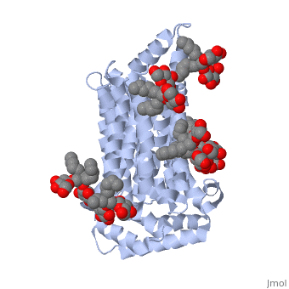

SLC2A3 gene (GLUT-3) was the third glucose transporter found. It was first cloned in 1988 from skeletal muscle cell line by the use of GLUT 1 CDNA probe and was noted to share 64.4% of GLUT 1 identity. Studies have shown that the SLC2A3 gene is associated with the risk of several clinical implications including hyperactivity disorder, chorea Huntington, congenital heart defects and rheumatoid arthritis.
Genomics
The SLC2A3 gene (GLUT 3) is located at 12p13.31 chromosome. The SLC2A3 gene location at 12p 13.31 chromosomes is not stable and is susceptible to non-allelic homologous recombination events, producing multiple copy number variants (CNVs) of SLC2A3 which is responsible for changes in SLC2A3 expression. SLC2A3 consist of 12 transmembrane segments (TMs) comprising of 3 repeated sections each. The protein has two ligands, Y01 and 37X. Glucose Neopentyl Glycol (37X) has a weight of 569 Da while the Cholestrol hemisuccinate (Y01) has a molecular weight of 487 Da. The protein consists of 496 amino acids which account for a molecular weight of 54 kDa. The closest neighbors of the SLC2A3 gene are GLUTs family comprising of 14 members, myoinositol transporter HMIT (SLC2A13), designated SLC2A1-SLC2A12, and SLC2A14. Most of the GLUTs members have CpG islands, Chromatin modifications, DNase I hypersensitivity and so does SLC2A3 gene. The SLC2A3 gene has 10 Exons. The table below shows the SLC2A3 gene variation in the 12p 13.31 chromosome.
Annotation release | Status | Assembly | Chr | Location
109.202110226 | Current | GRCh38.p13 (GCF 000001405.39) | 12 | NC 000012.12(79192330..7936187, complement)
105.20201022 | Previous assembly | GRCh37.p13 (GCF 000001405.25) | 12 | NC 000012.11 (8071826..8088783, complement)

Expression
The GLUT 3 protein is strongly expressed in the brain and testis membranes and in the spermatozoa. It is detectable in the membranes found in the erythrocytes, heart, liver, adipocytes, spleen, thyroid, kidney, prostate, and skeletal muscles. A Noncoding Intergenic Co-Induced transcript (NICI) transcription factor is present in the 12p 13.31 chromosome where SLC2A3 is located. The regulation of the SLC2A3 gene is by transcriptional activation but not posttranscriptional mechanisms the knockout of NICI results in low recruitment of RNA polymerase 2 to the SLC2A3 promoter.
FIG 2: Expression SLC2A3
Over expression of SLC2A3 is associated with poor prognosis in gastric cancer (GC). Figure a presents the overall survival (OS) curves (n (high) =192, n (low) =191) and the disease-free survival (DFS) curves for patients suffering from gastric cancer by SLC2A3 expression whereby (n (high) =192, n(low)=191). Overall survival curves of (n (high) =192, n (low) =192 and disease-free survival curves for gastric cancer patients by SLC2A6 expression (n (high) =192, n(low)=192). Figure b presents SLC2A3 mRNA expression in stomach adenocarcinoma (GEPIA database). Figure c is the representation of SLC2A3 mRNA expression in gastric cancer tissue and normal gastric mucosa. Figure d shows SLC2A3 IHC expression in gastric cancer samples, overall survival curve (n=44), and disease-free survival curve of SLC2A3 high and low groups in gastric cancer (n=40).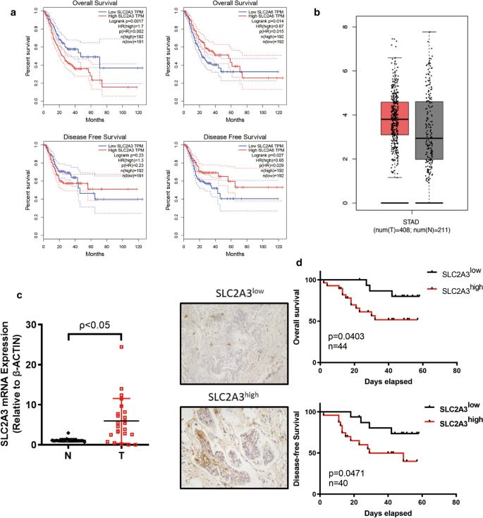
Variation
Several variations of SLC2A3 have been produced from its duplication. These variants have distinct properties based on tissue and substrate specificity. The recognition of copy number variants in the GLUT genes, including the SLC2A3 gene, implies that these rejoining events are still taking place and are responsible for both duplications and deletions of the gene. Examples of detected variants of the SLC2A3 gene comprise the entire SLC2A3 gene, the first two exons of SLC2A14, and the pseudogene NANOGP1. It can be concluded that the non-allelic homologous recombination (NAHR) is the possible cause of SLC2A3 copy number variations. The pseudogene NANOGP1 is the main copy number variant of the SLC2A3 gene of clinical interest (Mlynarski et al. 2015).
Evolutionary Conservation
Although the SLC2A3 gene is most dominant in mammals, one of its variants, NANOG, has been reported to be present as a single orthologue in all osteichthyans, except for the Xenopus species that appear to have lost the gene. This single NANOG gene has been noted in birds, eutherians, teleosts, and axolotl. The duplicate known as NANOGP1 or NANOGP2 has been detected in hominids. NANOGP1 and other pseudogenes have been detected in primates and rodents. Pluripotency of mammalian LIF-deprived ESCs has been maintained by the overexpression of chick Nanog. However, the axolotl NANOG is not able to maintain pluripotency in LIF deprived mouse ESCs. Zebra fish Nanog has been reported to maintain pluripotency when expressed in LIF-deprived mouse ESCs. Various duplications of SLC2A3 have gene has occurred including the NANOG family that have been detected in other organisms such as Guinea pig, birds, duck, and Indian python among others.

Appendices
- Full genomic sequence
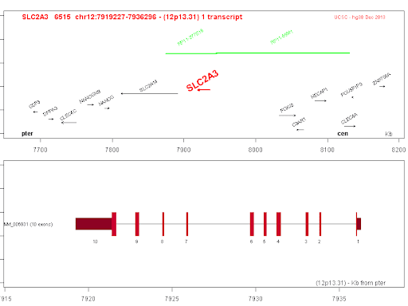

- mRNA Sequence
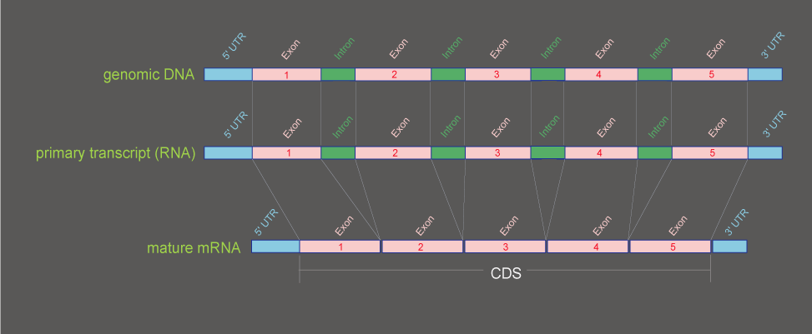

- SLC2A3 protein sequence
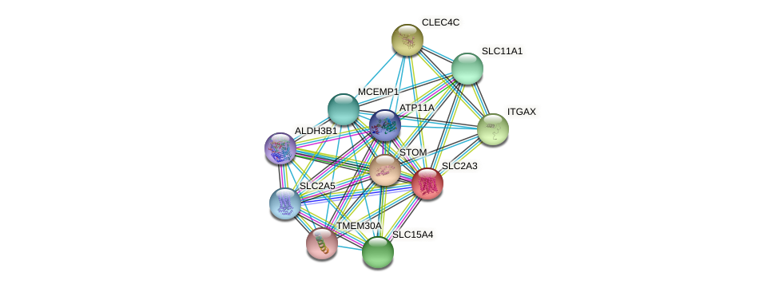

References
Mimura, I., Nangaku, M., Kanki, Y., Tsutsumi, S., Inoue, T., Kohro, T., ... & Wada, Y. (2012). Dynamic change of chromatin conformation in response to hypoxia enhances the expression of GLUT3 (SLC2A3) by cooperative interaction of hypoxia-inducible factor 1 and KDM3A. Molecular and cellular biology, 32(15), 3018-3032.
Mlynarski, E. E., Sheridan, M. B., Xie, M., Guo, T., Racedo, S. E., McDonald-McGinn, D. M., ... & International Chromosome 22q11. 2 Consortium. (2015). Copy-number variation of the glucose transporter gene SLC2A3 and congenital heart defects in the 22q11. 2 deletion syndrome. The American Journal of Human Genetics, 96(5), 753-764.

